Leatile Mogende
Bida25-127

WMD assignment 2026

Q1
a. The principal objective of a website is to provide relevant, useful, and engaging content to its audience while aligning with the mission, values and vision of the organization’s broader goals(Columbia sites 2026). Our website was designed to clearly communicate and deliver clear helpful information about the services we provide at MLS, Increase our digital presence to increase brand awareness and reach every corner of Botswana and generate leads that can be helpful in bringing in new clientele. Also accessibility was one of the key priorities when developing this website. We wanted to make it easy for our clients to access our services from their convenient location without the need to physically come to our office.

b. A target audience is a defined group characterized by shared demographics, behaviors , needs, and interests (SiteCove Learning Center 2026). MLS’s target audience is people of the age of 18-35. These are the people who are disadvantaged by the system when it comes to access to services like loans, so we took advantage of this gap to provide our services to people within this demographic who fits our eligibility criteria.
Location- we target people who stay in urban/suburban areas because they have access to internet infrastructure that allows them to use our website smoothly, and also most universities and workplaces are in urban/suburban areas and one of our requirements are that we only provide our services to people with a source of income and people in this demographic fit perfectly.
Technical Aptitude- most user with the age of 18-35 have smart phones and they have strong digital presence, so they are familiar with navigating websites and mobile browsing. So we targeted them because its easier to reach them through digital platforms and it will not be difficult for them understand and interact with your website since they have digital background.

c. The website I am designing falls under the category of service based site. It will display the services that MLS provides, an interactive form that users can use to apply for our services and display text that will educate the user about MLS and who we are.

Q 2.
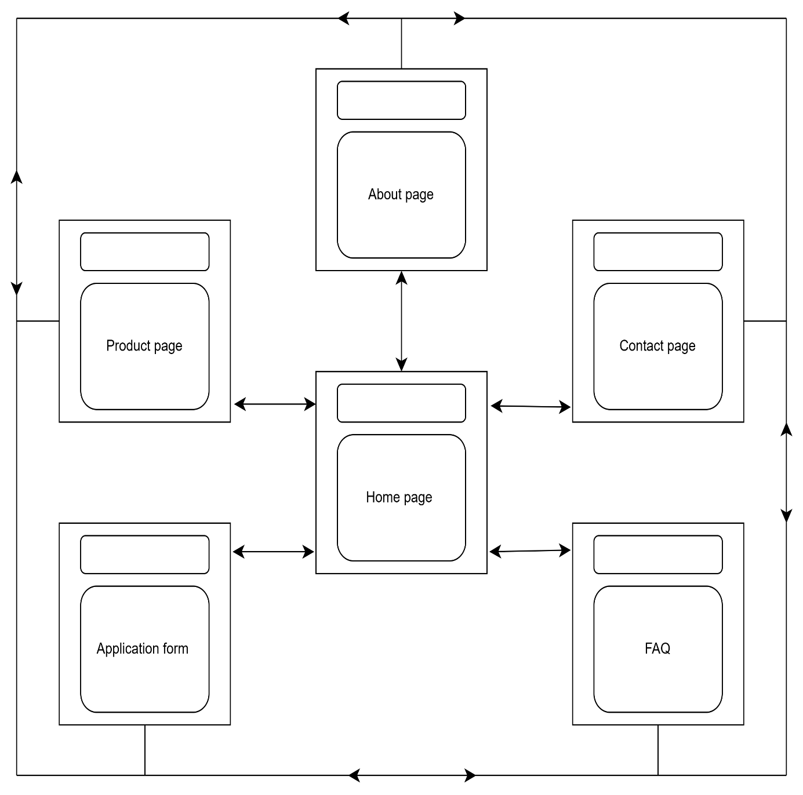
The home page has the navigation bar that that has links of Product page, about page, contact page, FAQ, and Application form which enables the user to move from one page to the other. All pages have the navigation bar so the user can jump from any page in the website to the other without any hierarchical process.

Q 3
Home page wire frame
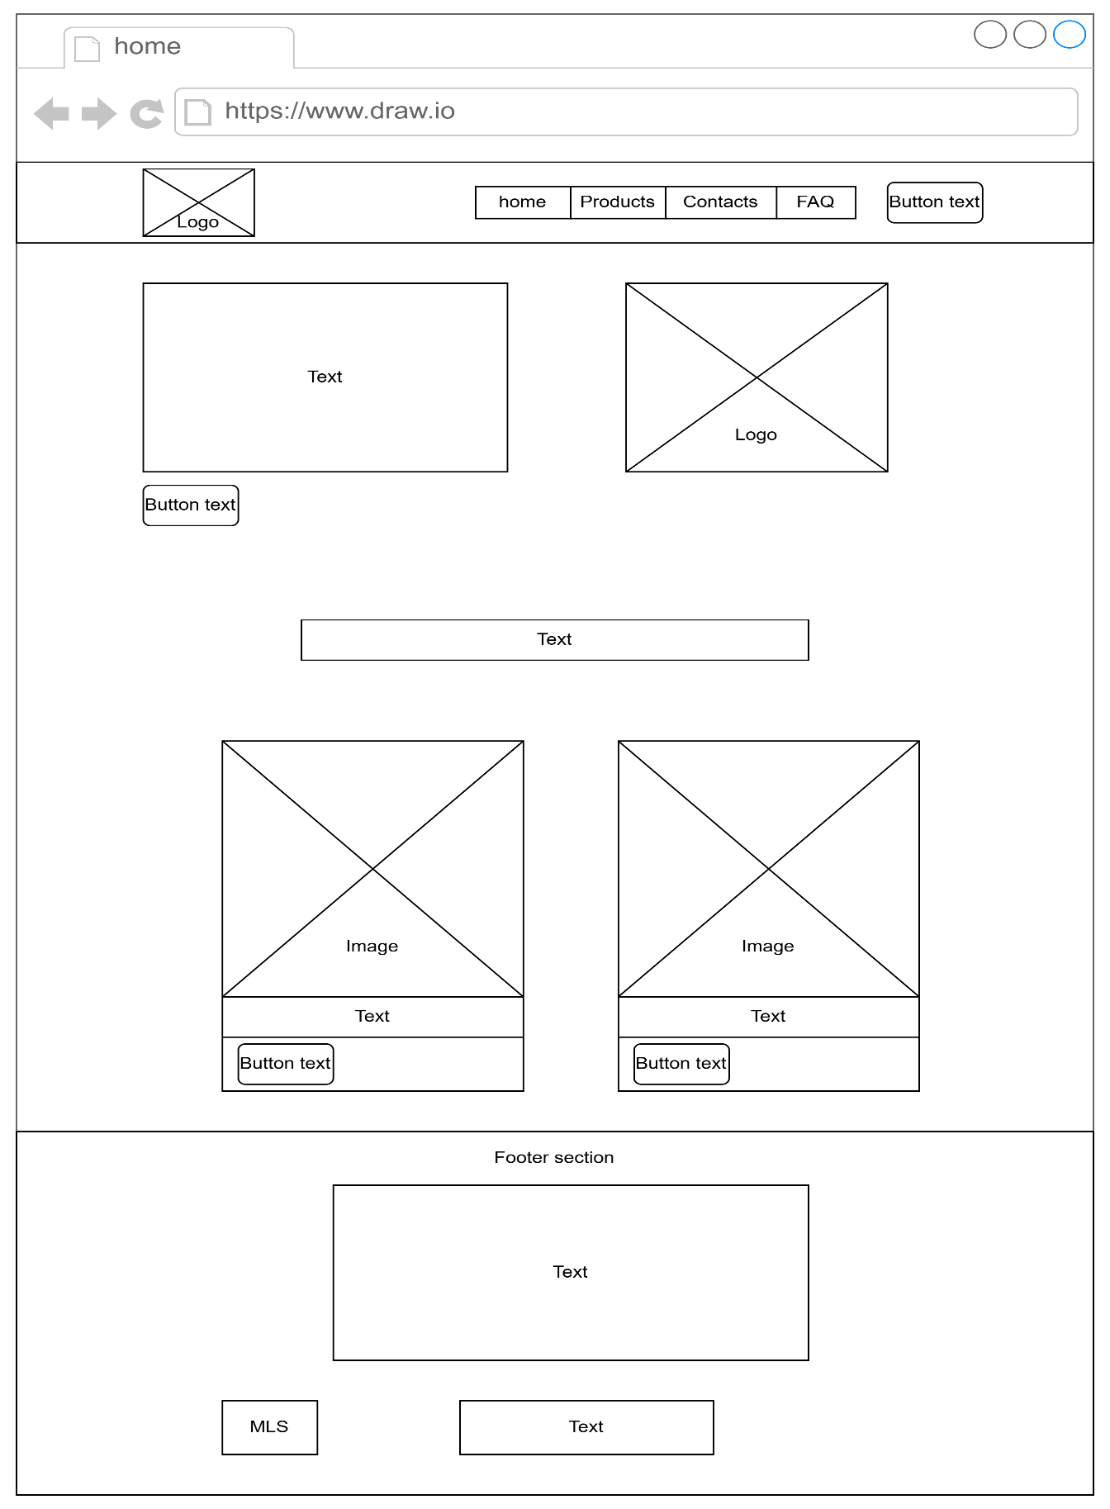
This diagram depicts how content will be displayed on the home page.

This is the high fidelity wireframe for the home page
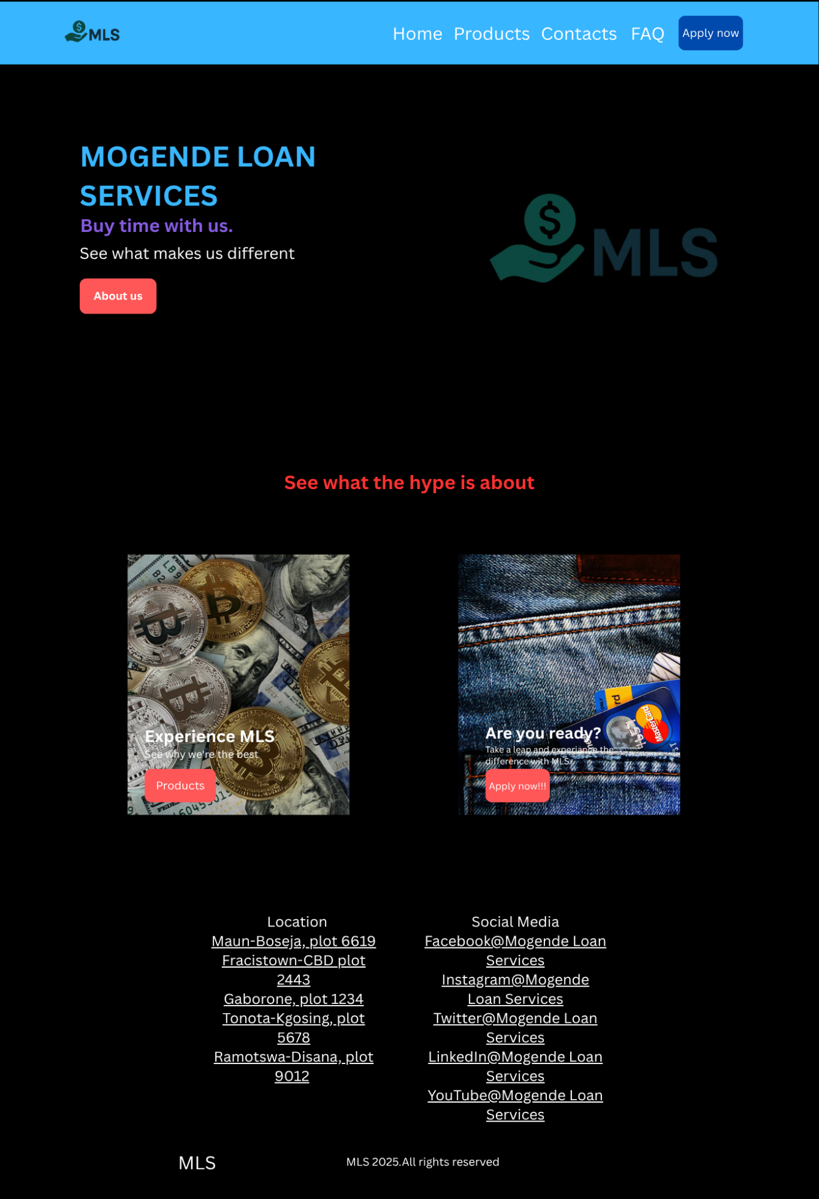

About wireframe
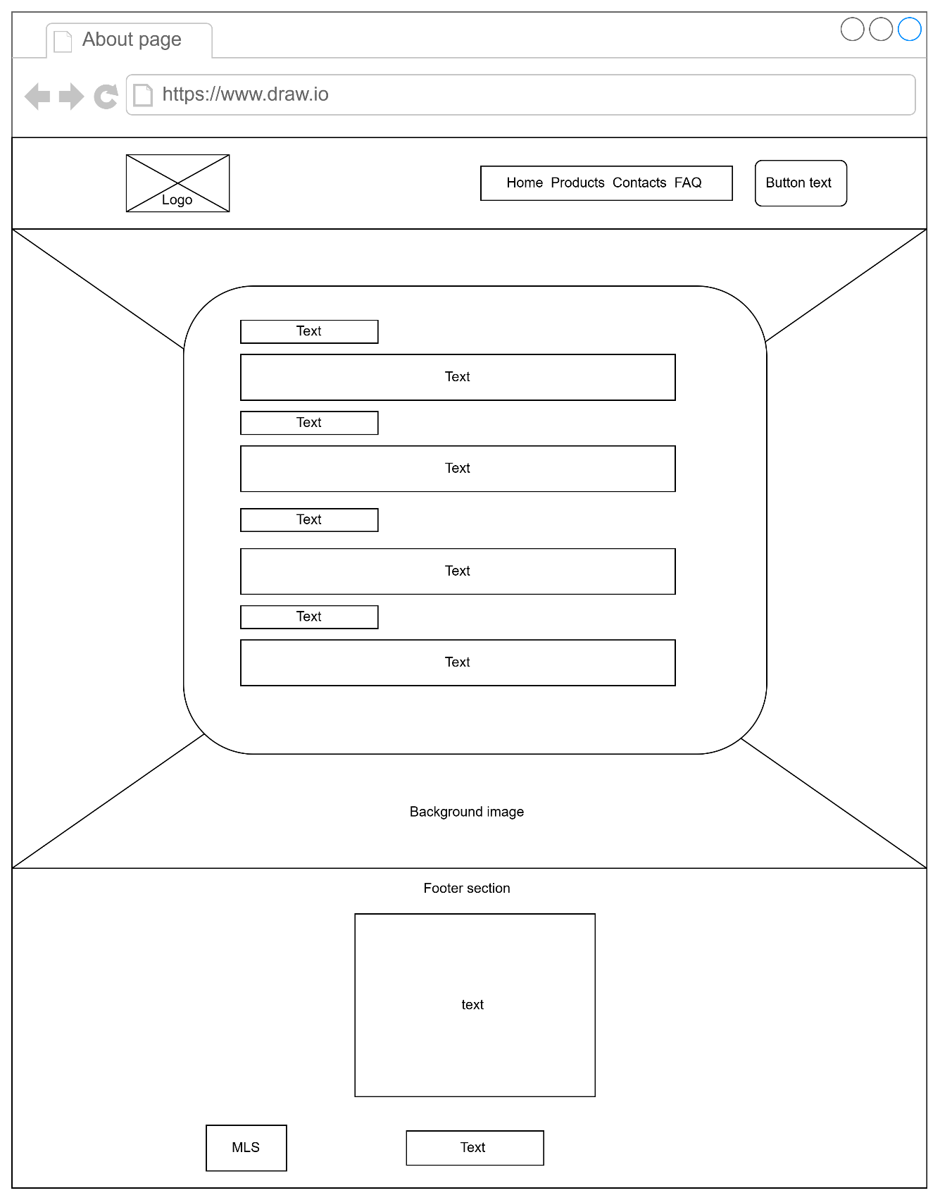
This is the wireframe for the about page and it is consistent with the other pages.

This is the high fidelity wireframe for the about page. It depicts how content will be displayed in the about page and it is consistent with other pages of the website except for the home page
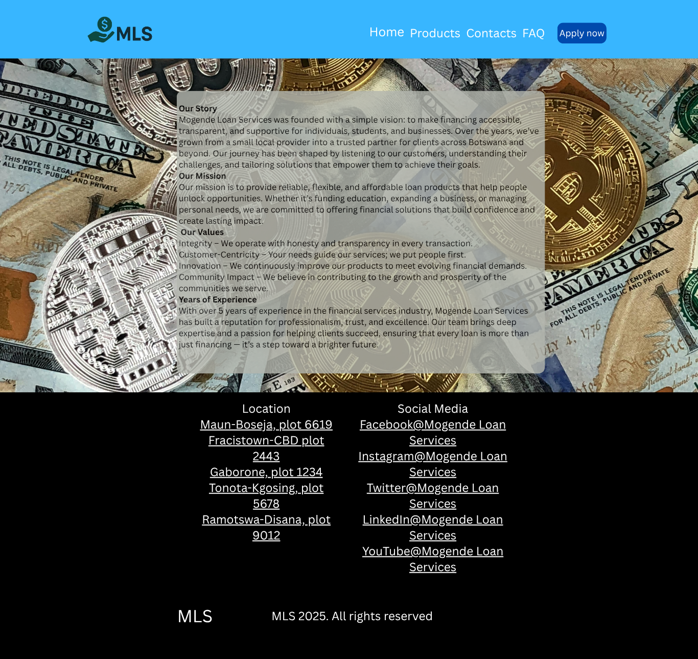

Product page wireframe
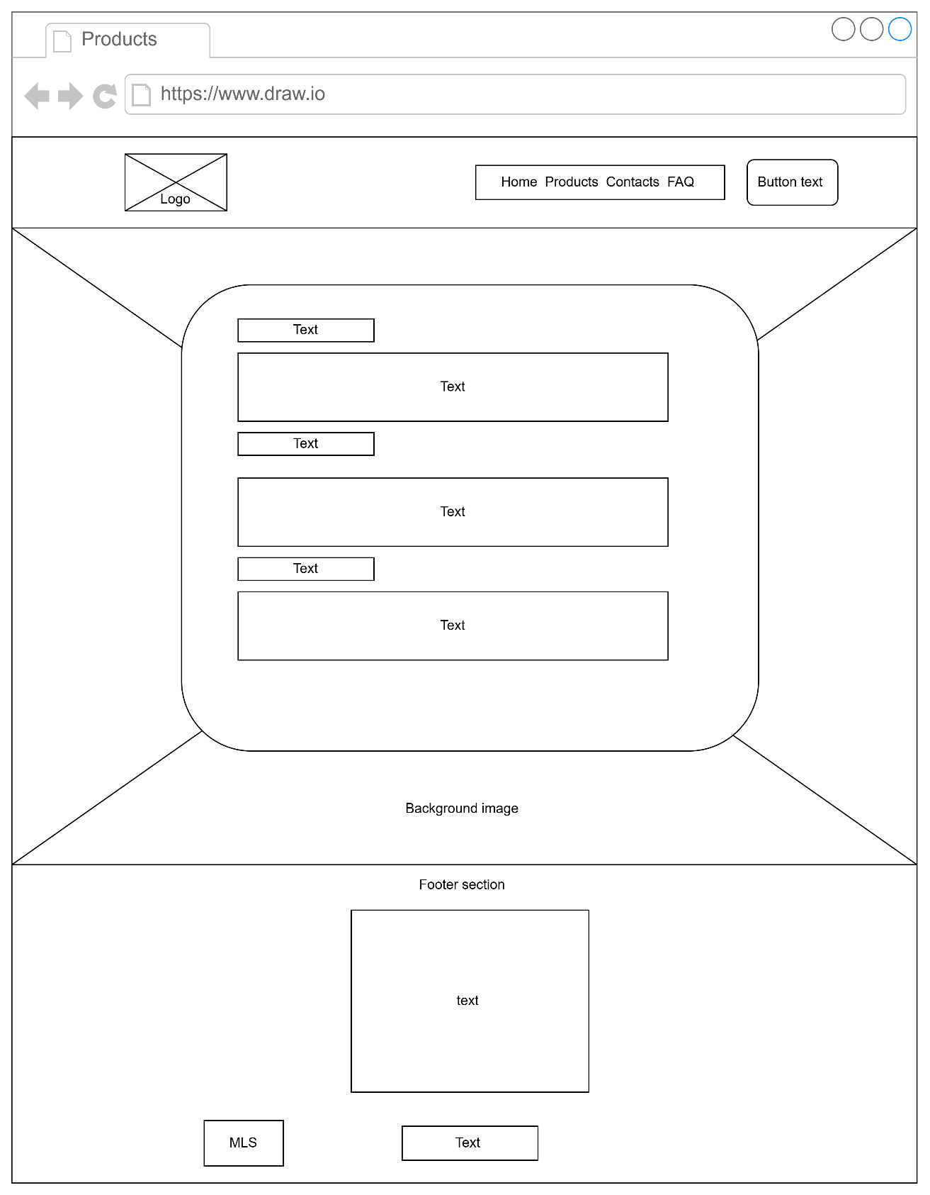

This diagram depicts how content will be displayed on the product page.

Agent directory page wireframe
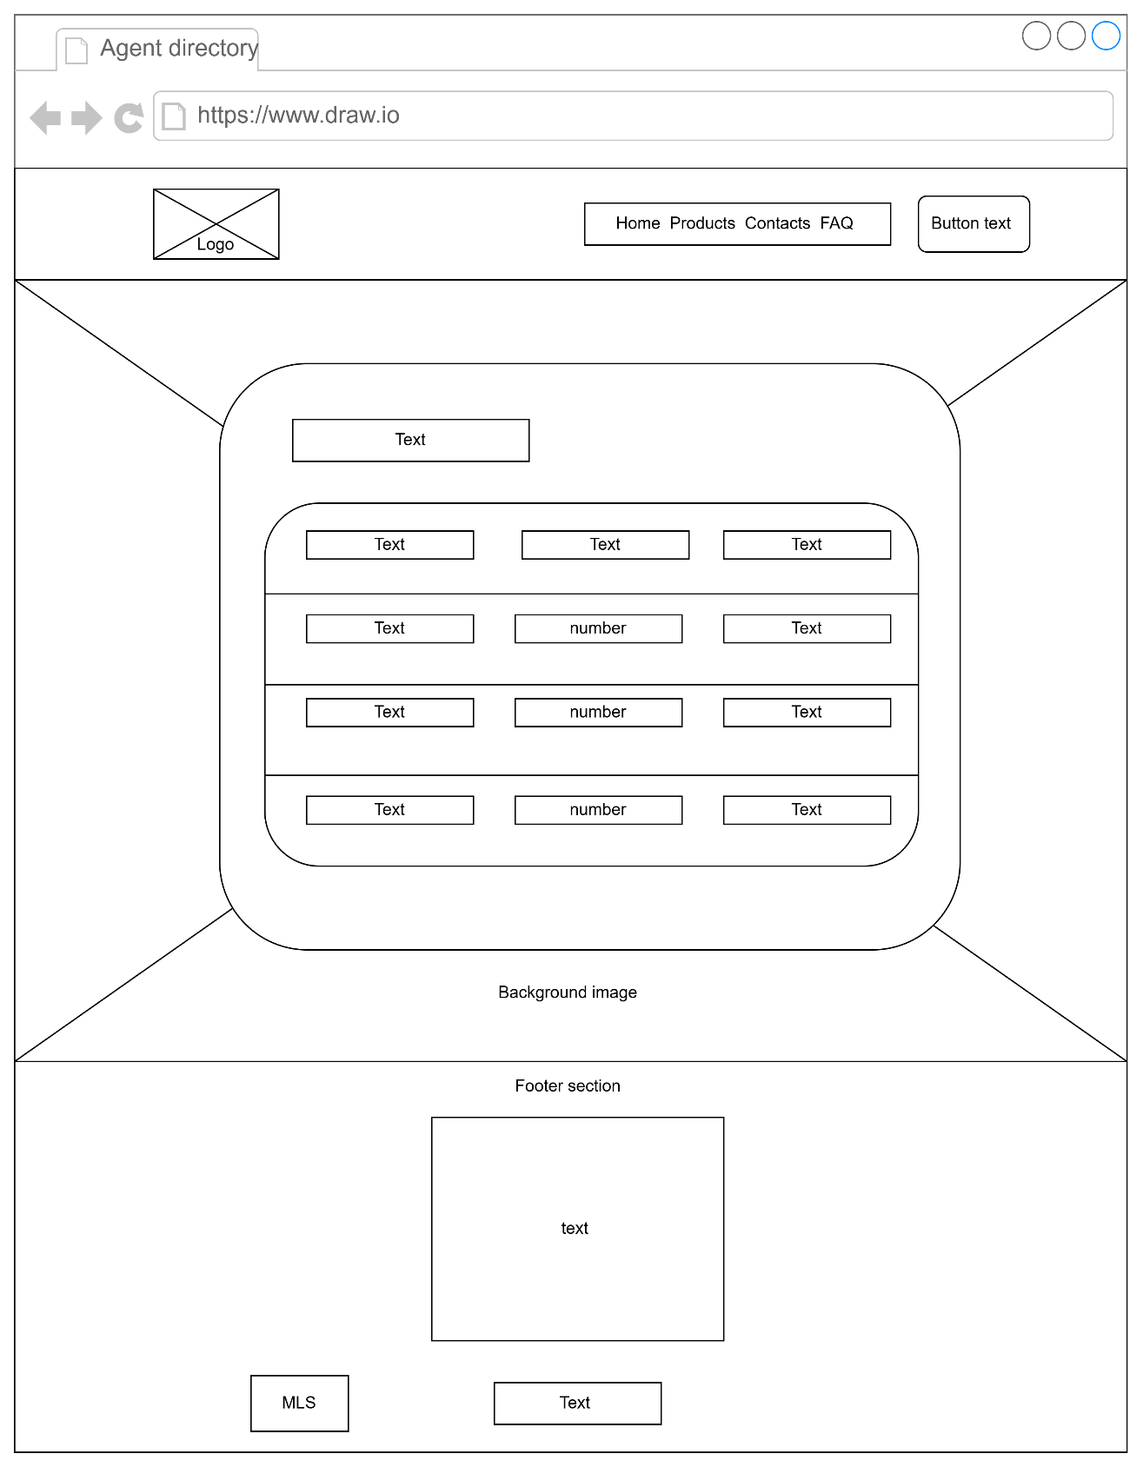
This diagram depicts how content will be displayed on the Agent directory page.

FAQ page wireframe
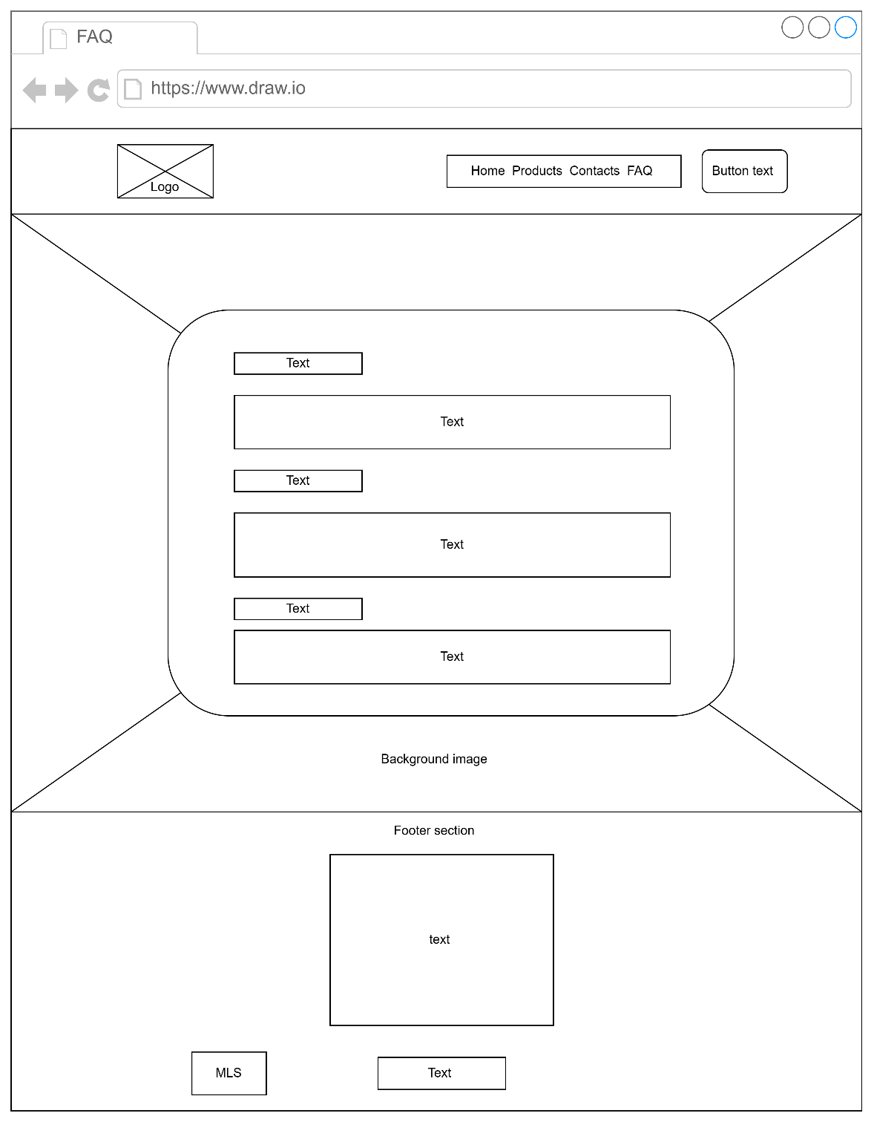
This diagram depicts how content will be displayed on the FAQ page.

Application form wireframe
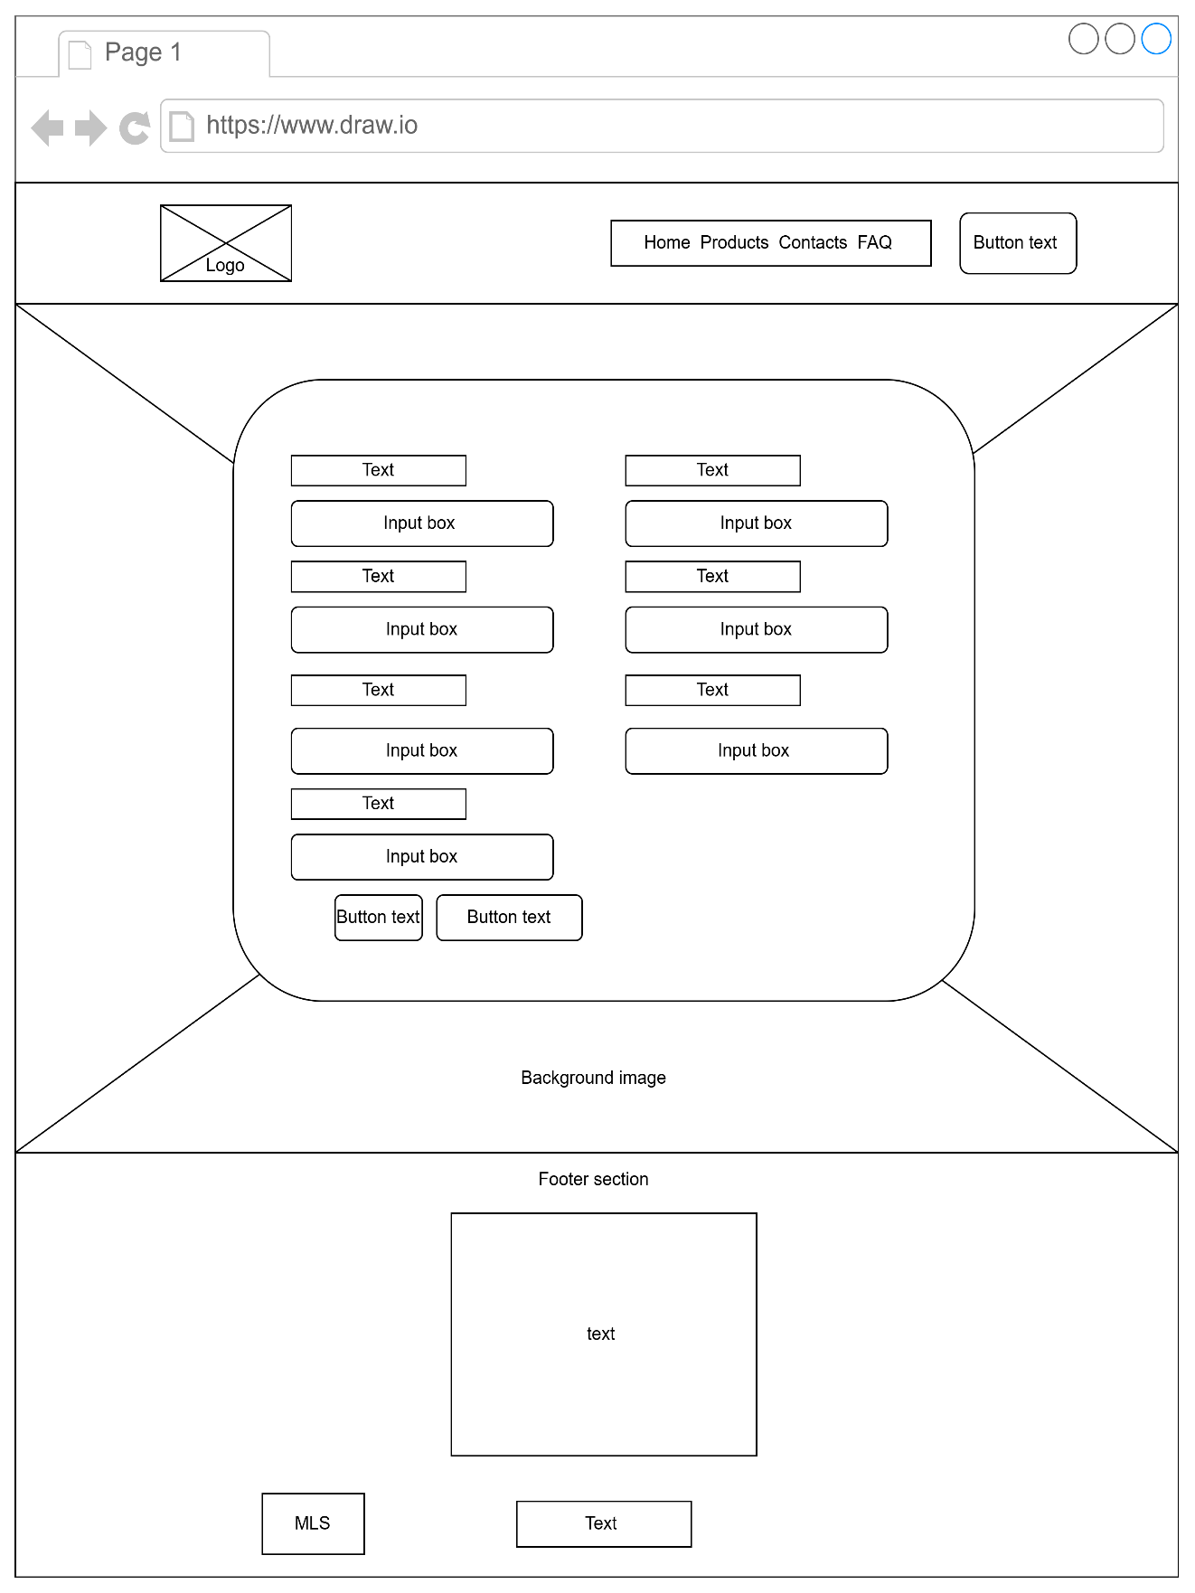
This diagram depicts how content will be displayed on the Application form page.

Part B
Structural layer- HTML5
Index.html
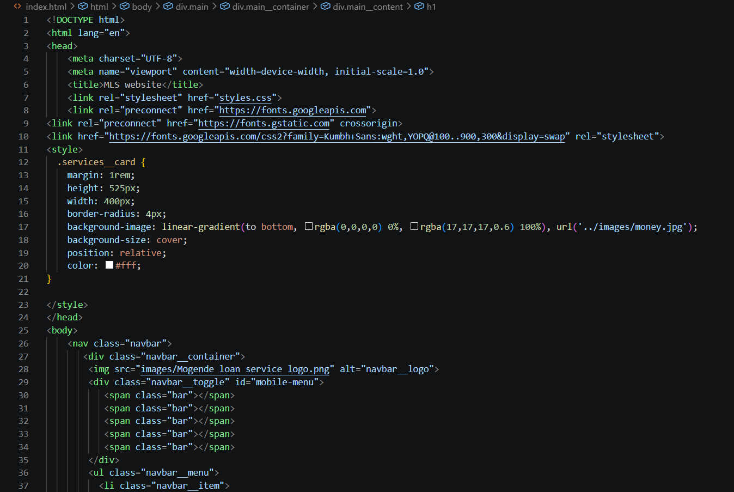
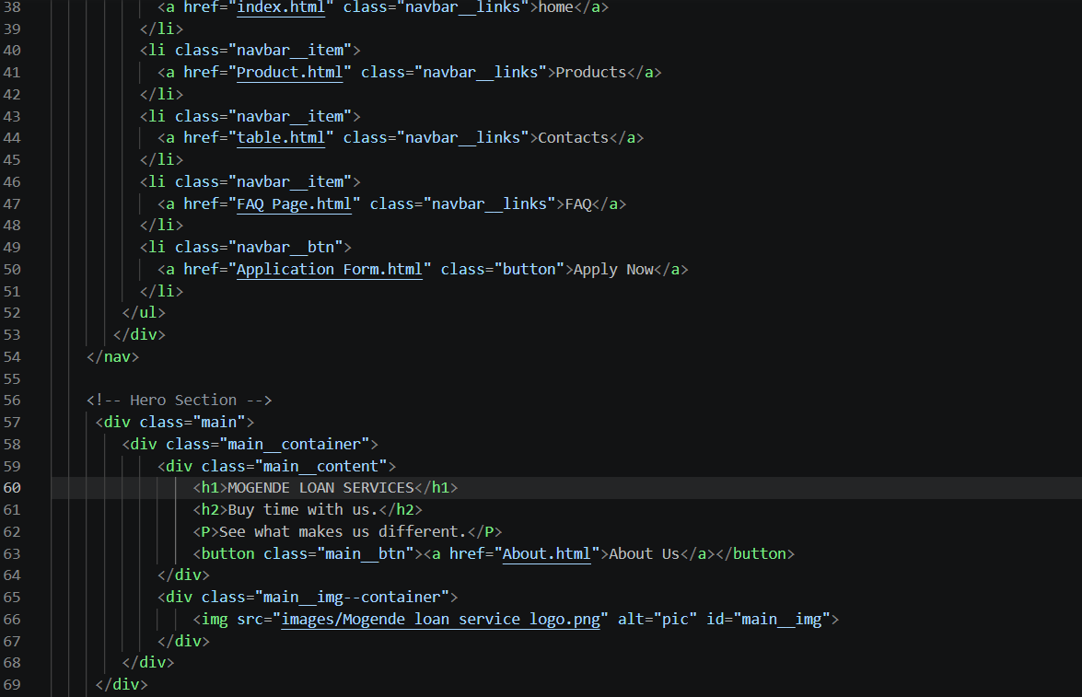
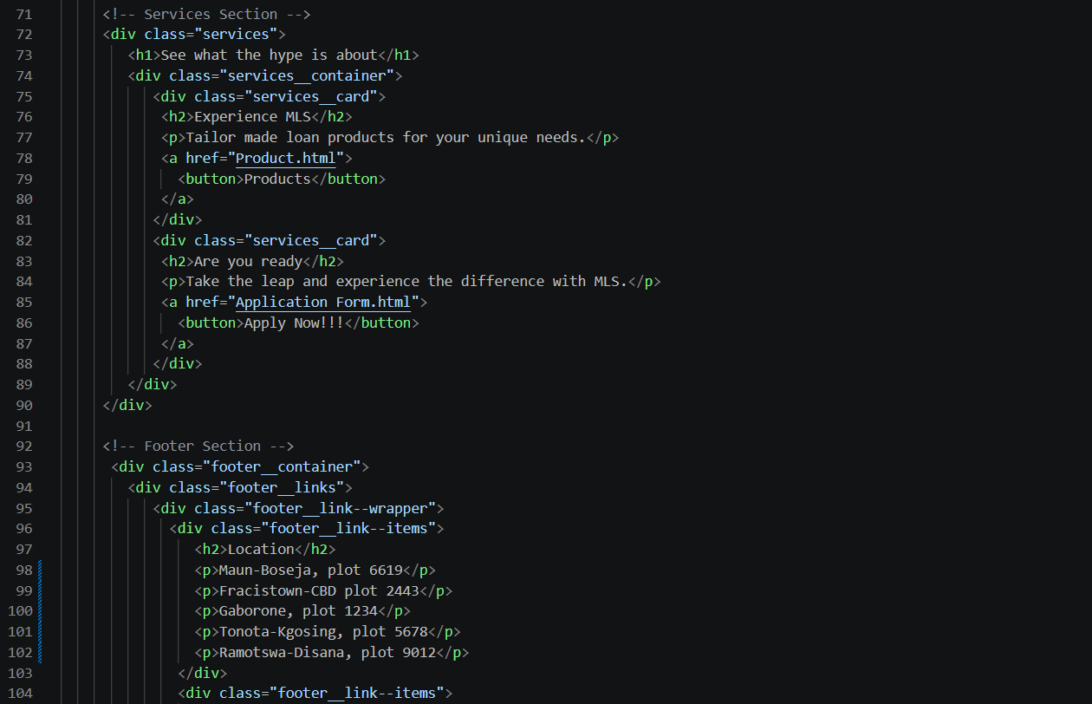
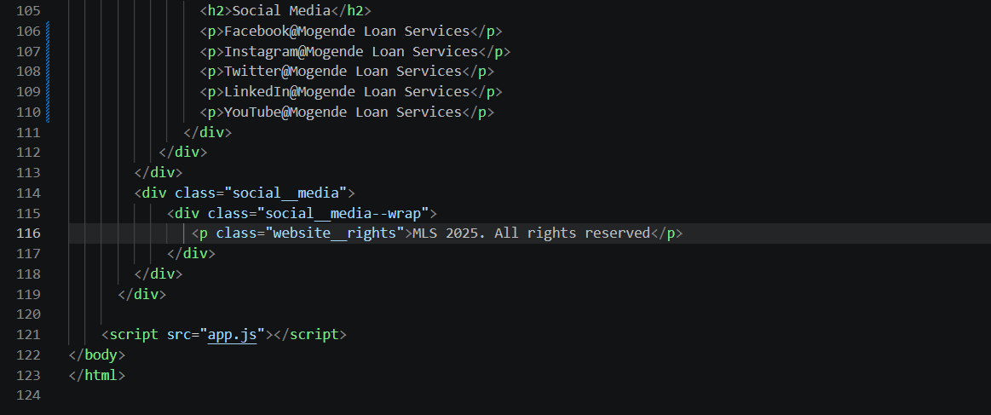
<!DOCTYPE html> Declares the document as HTML5 for the browser to render correctly.
<html lang=”en”> Root element of the webpage lang specifies the content is written in English.
<head> contains the metadata and links of external resources.
<meta charset= “UTF-8”> defines character encoding allowing text and symbols to display correctly
<meta name=”viewport” content=”width= device-width, initial-scale=1.0”> ensures webpage is responsive and displays properly on different screen sizes
<title> sets the title of the webpage displayed on the browser
Styles.css- links external css file used to style the look of the webpage
<link rel=”preconnect”> improves loading performance of the webpage by establishing early connections to google fonts servers
https://fonts.googleapis.com/ . imports Kumbh sans
<style> contains internal css used to style elements within the html file
<body> contains content that will be visible in the webpage
<nav> defines the navigation bar section of the webpage
<div> container element used to group content for styling and layout purpose
<img> displays image on the webpage
<span> inline element used here to create the bar of the mobile menu
<ul> creates an unordered list for navigation links
<li> represents individual items of a list
<a> tag used to create hyperlinks to other pages
<button> clickable button for user action
<h1> main heading of the webpage
<h2> secondary heading for the sub title
<p> paragraph tag used to display text content
<div class=”services”> groups the services content
< div class=”services__container” holds all service cards
<div class="services__card”> represents individual service offerings displayed as cards.
<div class="footer__container”> main container for the footer
<h2> footer headings
<p> display text content of the footer
App.js</script> links an external javascript file used for interactivity
</body> ends the visible content of the webpage
</html> ends the html document

About.html
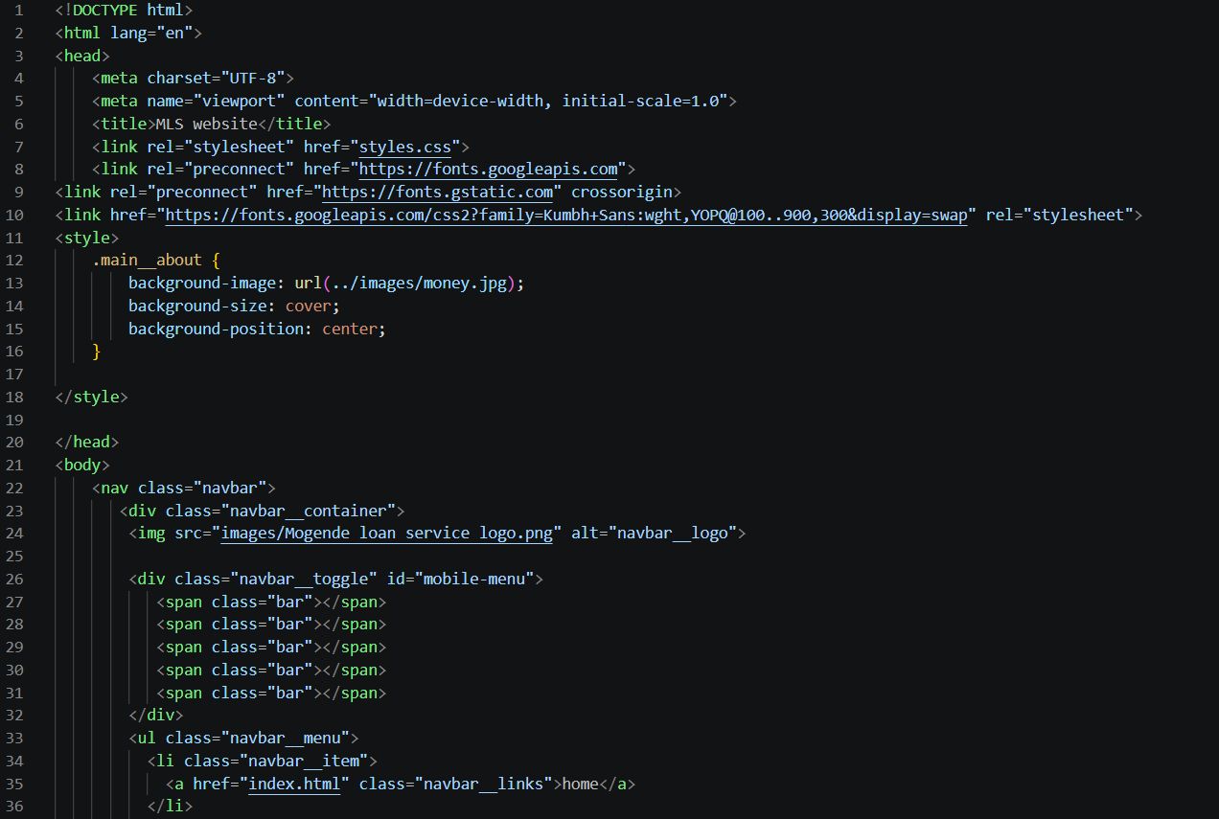
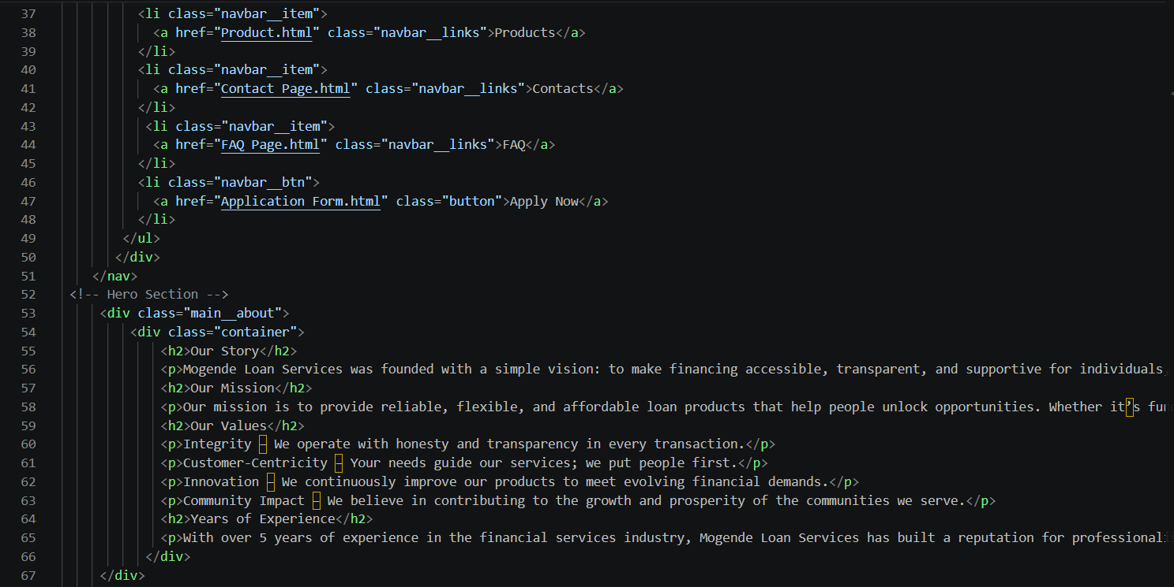
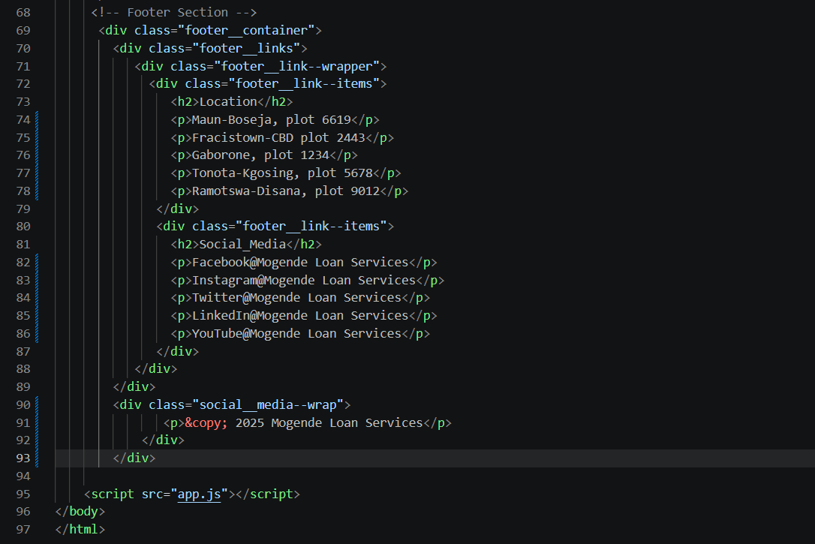
<!DOCTYPE html> Declares the document as HTML5 for the browser to render correctly.
<html lang=”en”> Root element of the webpage lang specifies the content is written in English.
<head> contains the metadata and links of external resources.
<meta charset= “UTF-8”> defines character encoding allowing text and symbols to display correctly
<meta name=”viewport” content=”width= device-width, initial-scale=1.0”> ensures webpage is responsive and displays properly on different screen sizes
<title> sets the title of the webpage displayed on the browser
Styles.css- links external css file used to style the look of the webpage
<link rel=”preconnect”> improves loading performance of the webpage by establishing early connections to google fonts servers
https://fonts.googleapis.com/ . imports Kumbh sans
<style> contains internal css used to style elements within the html file
.main__about- applies stylling to the about section. Adds background image, sets background size and centers the background image
<body> contains content that will be visible in the webpage
<nav> defines the navigation bar section of the webpage
<div> container element used to group content for styling and layout purpose
<img> displays image on the webpage
<span> inline element used here to create the bar of the mobile menu
<ul> creates an unordered list for navigation links
<li> represents individual items of a list
<a> tag used to create hyperlinks to other pages
<button> clickable button for user action
<div class=”main__about”> defines the about section
<div class="container”> wraps the content inside the section for better layout
<h2> heading tag used for section titles
<p> paragraph tag used for text information display on the webpage
<div class="footer__container”> main container for the footer
<h2> footer headings
<p> display text content of the footer
<p class=”website__rights”> display copyright information
App.js</script> links an external javascript file used for interactivity
</body> ends the visible content of the webpage
</html> ends the html document

Product.html
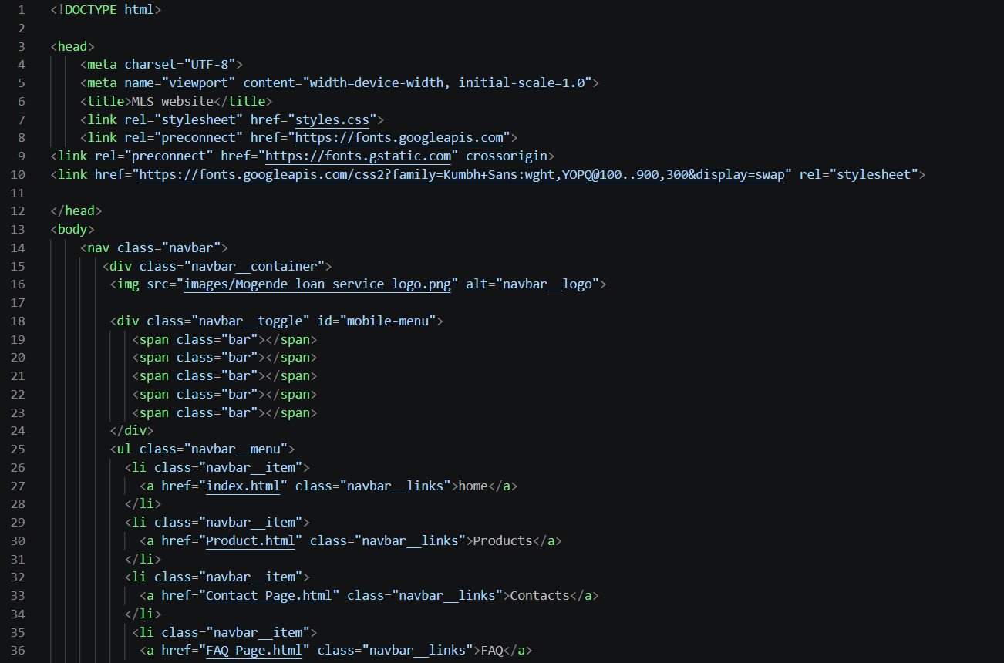
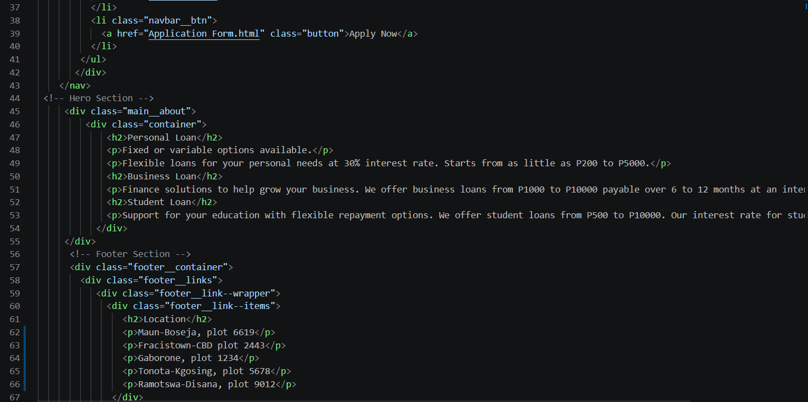
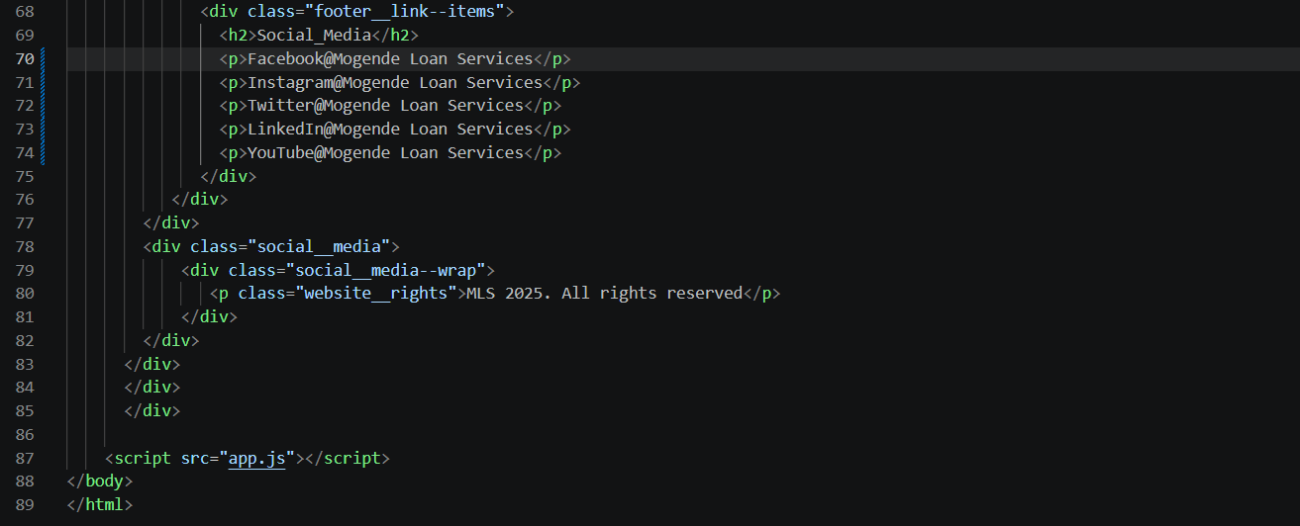

<!DOCTYPE html> Declares the document as HTML5 for the browser to render correctly.
<html lang=”en”> Root element of the webpage lang specifies the content is written in English.
<head> contains the metadata and links of external resources.
<meta charset= “UTF-8”> defines character encoding allowing text and symbols to display correctly
<meta name=”viewport” content=”width= device-width, initial-scale=1.0”> ensures webpage is responsive and displays properly on different screen sizes
<title> sets the title of the webpage displayed on the browser
Styles.css- links external css file used to style the look of the webpage
<link rel=”preconnect”> improves loading performance of the webpage by establishing early connections to google fonts servers
https://fonts.googleapis.com/ . imports Kumbh sans
<body> contains all the visible content of the webpage
<nav> defines the navigation bar of the website
<div> container element used to group content for styling and layout purpose
<img> displays image on the webpage
<span> inline element used here to create the bar of the mobile menu
<ul> creates an unordered list for navigation links
<li> represents individual items of a list
<a> tag used to create hyperlinks to other pages
<button> clickable button for user action
<div class=”main__about”> defines the main content section for loan information
<div class="container”> holds and aligns the content inside the section
< h2> heading tag for loan titles
<p> paragraph tag used to display descriptive text
<div class="footer__container”> main container for the footer
<h2> footer headings
<p> display text content of the footer
<p class=”website__rights”> display copyright information
App.js</script> links an external javascript file used for interactivity
</body> ends the visible content of the webpage
</html> ends the html document

Contact.html
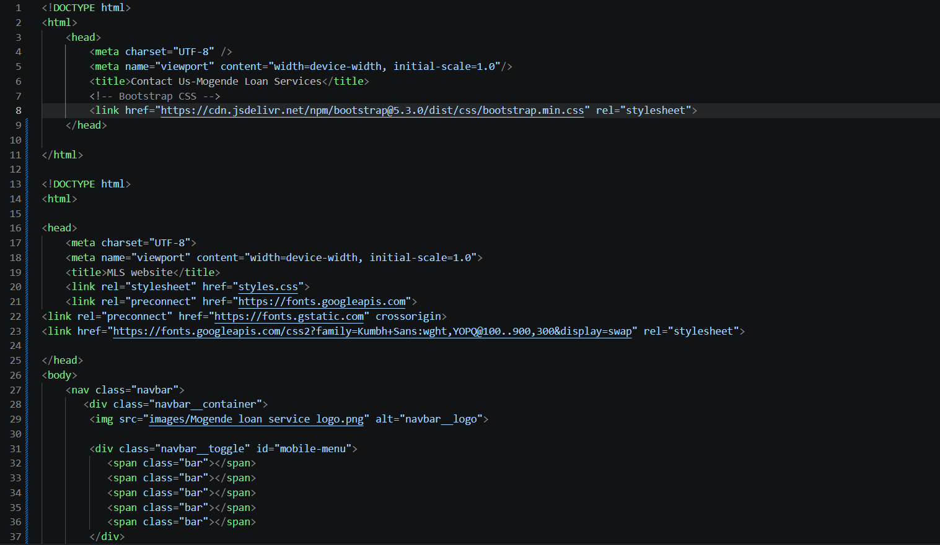
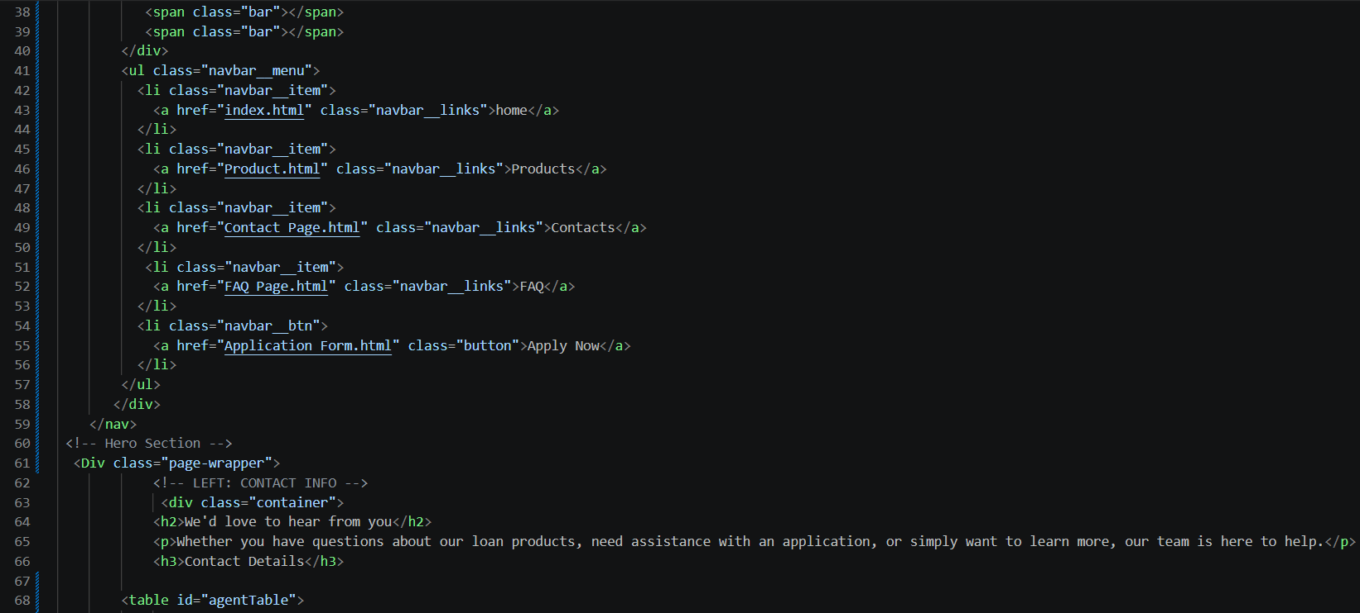
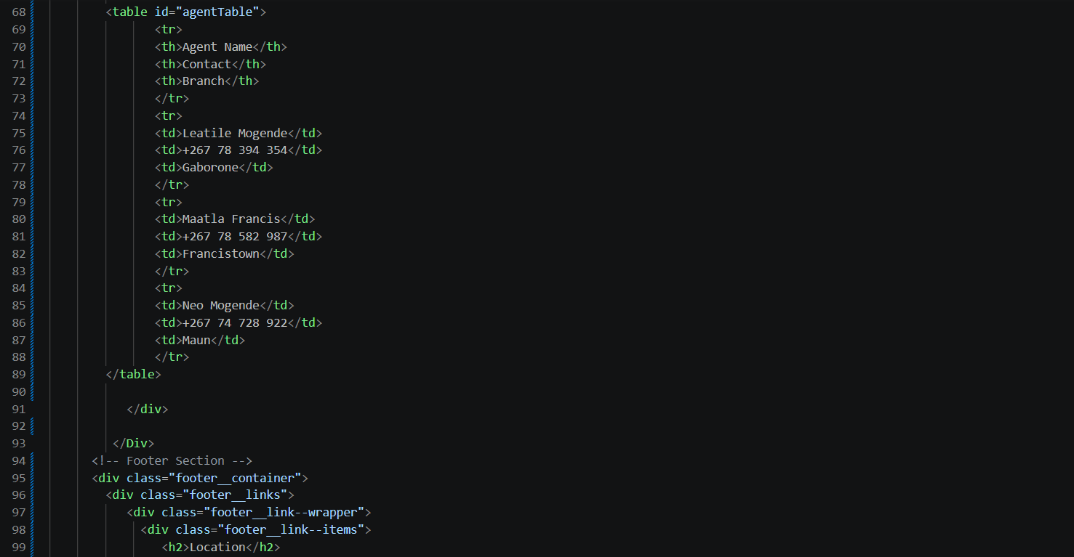
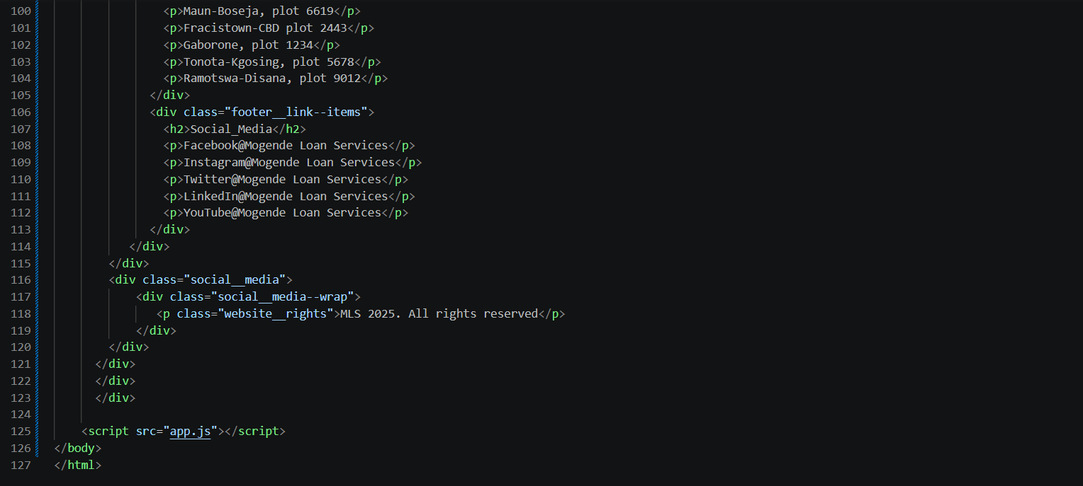

<!DOCTYPE html> Declares the document as HTML5 for the browser to render correctly.
<html lang=”en”> Root element of the webpage lang specifies the content is written in English.
<head> contains the metadata and links of external resources.
<meta charset= “UTF-8”> defines character encoding allowing text and symbols to display correctly
<meta name=”viewport” content=”width= device-width, initial-scale=1.0”> ensures webpage is responsive and displays properly on different screen sizes
<title> sets the title of the webpage displayed on the browser
Styles.css- links external css file used to style the look of the webpage
<link rel=”preconnect”> improves loading performance of the webpage by establishing early connections to google fonts servers
https://fonts.googleapis.com/ . imports Kumbh sans
<body> contains all the visible content of the webpage
<nav> defines the navigation bar of the website
<div> container element used to group content for styling and layout purpose
<img> displays image on the webpage
<span> inline element used here to create the bar of the mobile menu
<ul> creates an unordered list for navigation links
<li> represents individual items of a list
<a> tag used to create hyperlinks to other pages
<button> clickable button for user action
<div class=”page-wrapper”> wraps the main content area of the webpage
<h2> heading tag for the section title
<h3> smaller heading for subsection
<p> paragraph tag for displaying text content
<table> creates a table to display contact information
<tr> defines table rows
<th> table header cells
<td> defines table data cells containing information
<div class="footer__container”> main container for the footer
<h2> footer headings
<p> display text content of the footer
<p class=”website__rights”> display copyright information
App.js</script> links an external javascript file used for interactivity
</body> ends the visible content of the webpage
</html> ends the html document

FAQ.html
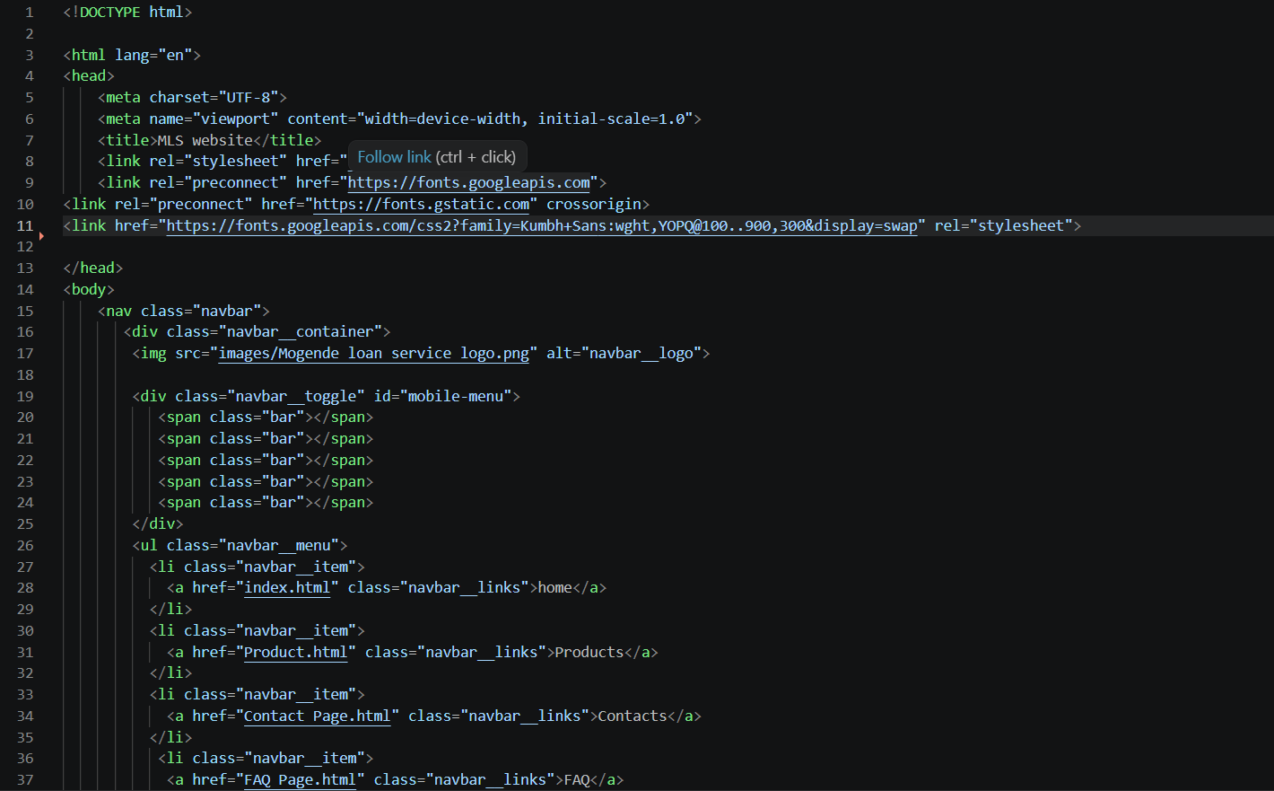
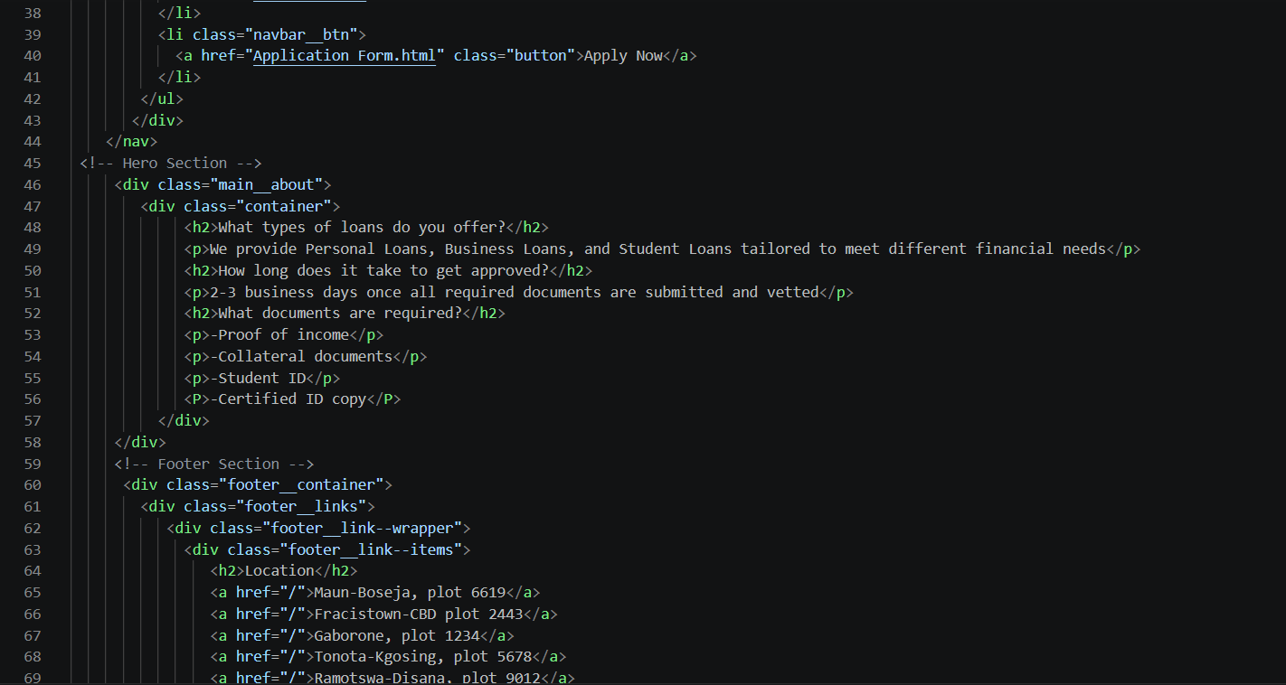
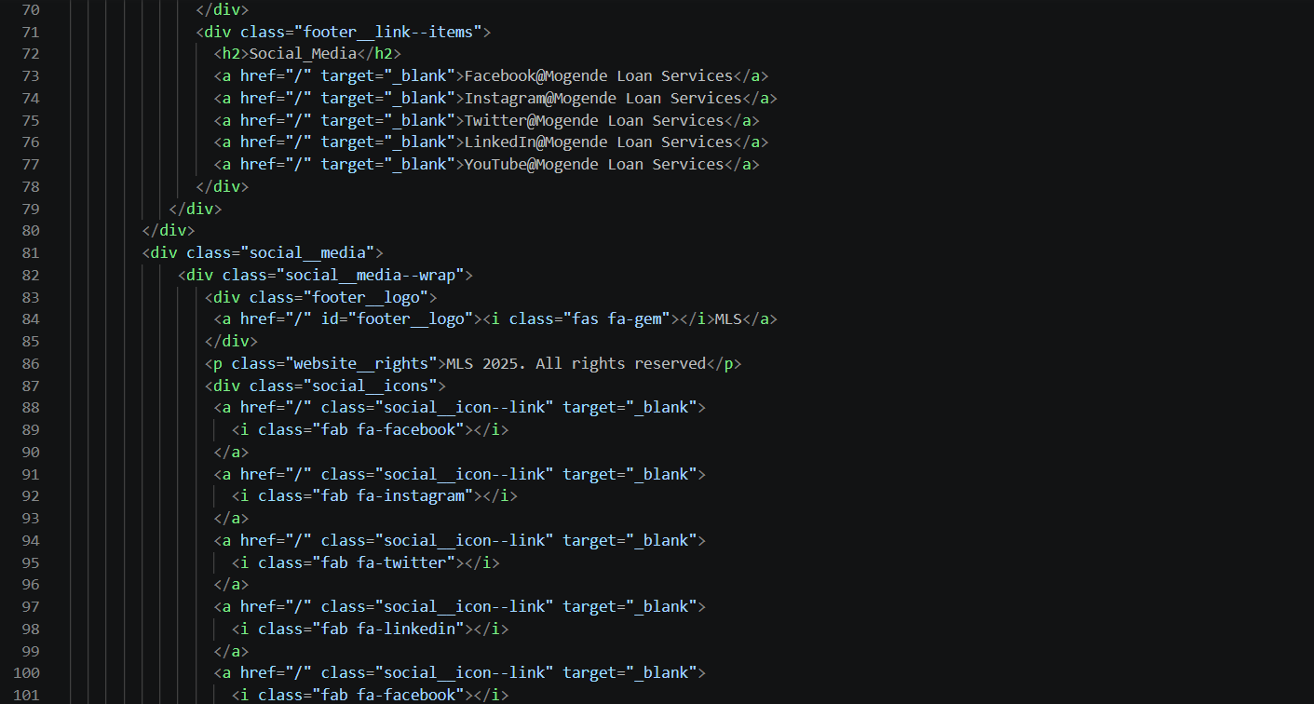
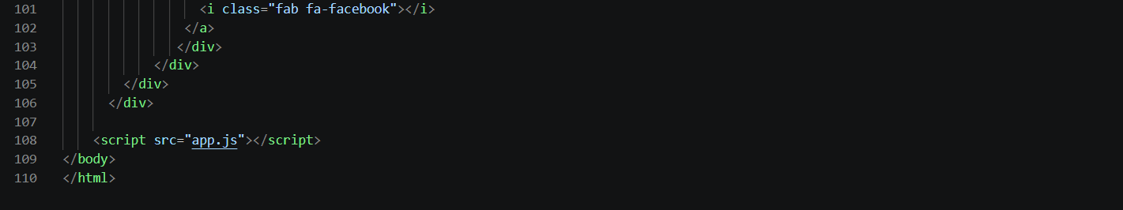

<!DOCTYPE html> Declares the document as HTML5 for the browser to render correctly.
<html lang=”en”> Root element of the webpage lang specifies the content is written in English.
<head> contains the metadata and links of external resources.
<meta charset= “UTF-8”> defines character encoding allowing text and symbols to display correctly
<meta name=”viewport” content=”width= device-width, initial-scale=1.0”> ensures webpage is responsive and displays properly on different screen sizes
<title> sets the title of the webpage displayed on the browser
Styles.css- links external css file used to style the look of the webpage
<link rel=”preconnect”> improves loading performance of the webpage by establishing early connections to google fonts servers
https://fonts.googleapis.com/ . imports Kumbh sans
<body> contains all the visible content of the webpage
<nav> defines the navigation bar of the website
<div> container element used to group content for styling and layout purpose
<img> displays image on the webpage
<span> inline element used here to create the bar of the mobile menu
<ul> creates an unordered list for navigation links
<li> represents individual items of a list
<a> tag used to create hyperlinks to other pages
<button> clickable button for user action
<div class=”main__about”> define main content of FAQ page
<div class="container”> wraps and align content for proper layout
<h2> heading tag for FAQ questions
<p> paragraph tag use to display text answers for FAQ questions
<div class="footer__container”> main container for the footer
<h2> footer headings
<p> display text content of the footer
<p class=”website__rights”> display copyright information
App.js</script> links an external javascript file used for interactivity
</body> ends the visible content of the webpage
</html> ends the html document

Application form.html
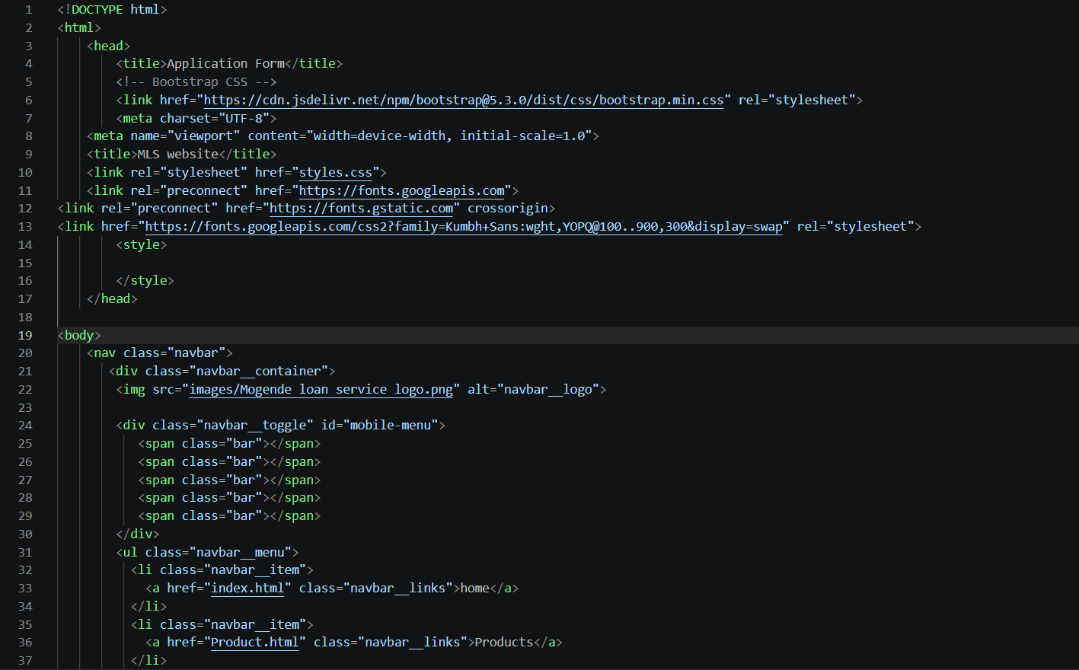
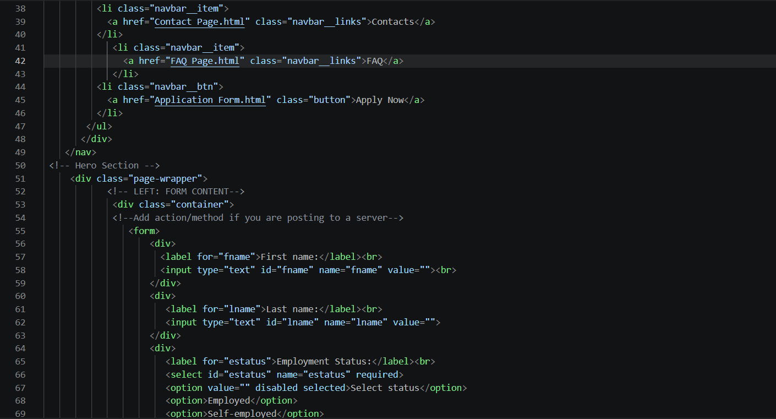
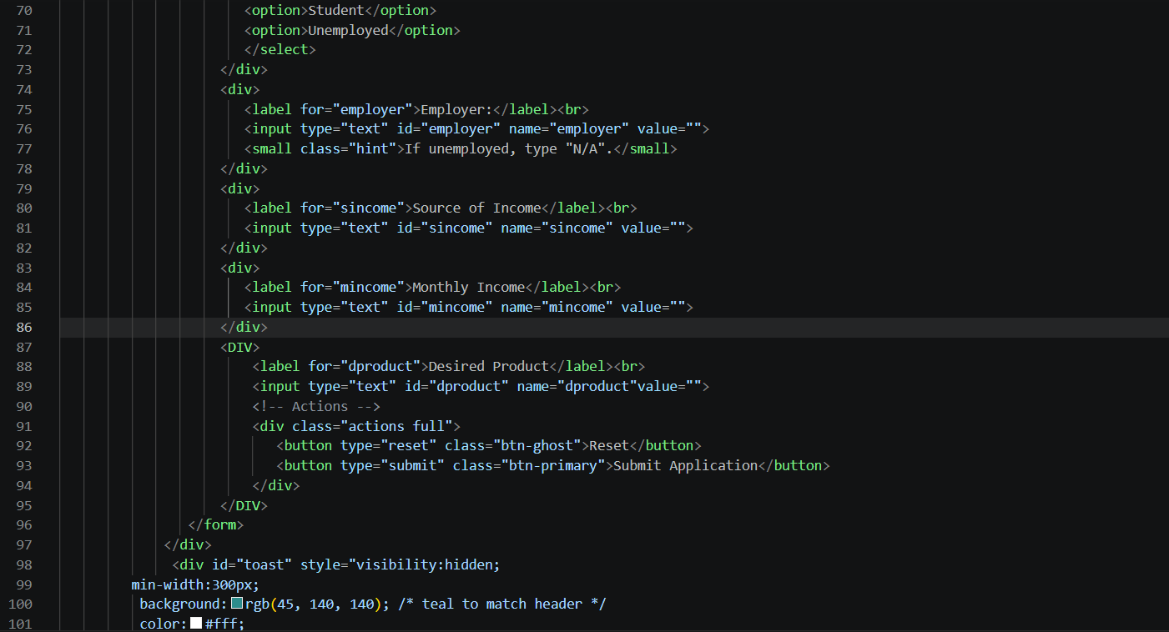
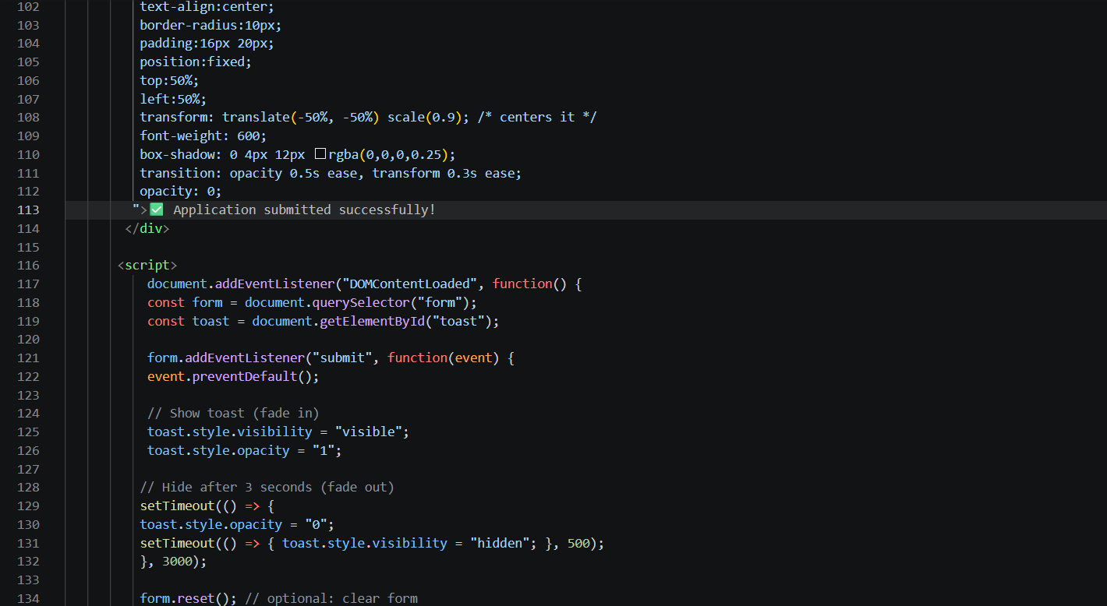
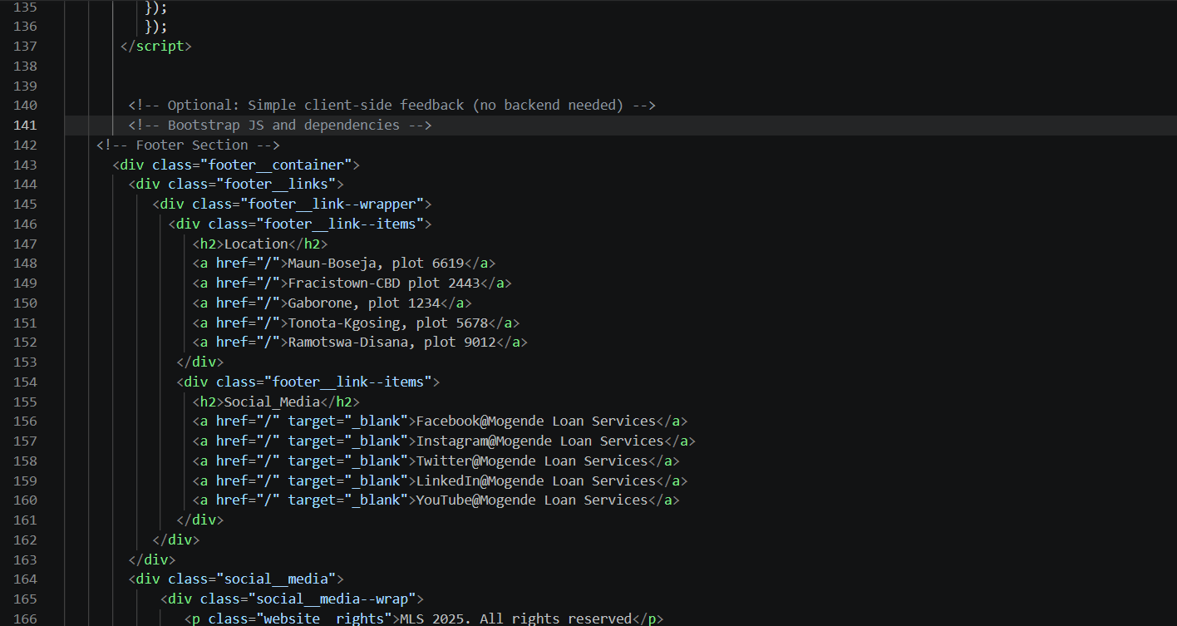
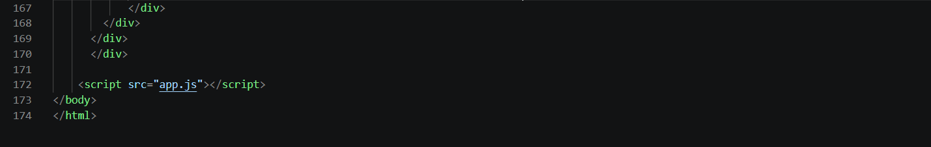
<!DOCTYPE html> Declares the document as HTML5 for the browser to render correctly.
<html lang=”en”> Root element of the webpage lang specifies the content is written in English.
<head> contains the metadata and links of external resources.
<meta charset= “UTF-8”> defines character encoding allowing text and symbols to display correctly
<meta name=”viewport” content=”width= device-width, initial-scale=1.0”> ensures webpage is responsive and displays properly on different screen sizes
<title> sets the title of the webpage displayed on the browser
Styles.css- links external css file used to style the look of the webpage
<link rel=”preconnect”> improves loading performance of the webpage by establishing early connections to google fonts servers
https://fonts.googleapis.com/ . imports Kumbh sans
<style> used to write internal css directly in the html document
<body> contains all the visible content of the webpage
<nav> defines the navigation bar of the website
<div> container element used to group content for styling and layout purpose
<img> displays image on the webpage
<span> inline element used here to create the bar of the mobile menu
<ul> creates an unordered list for navigation links
<li> represents individual items of a list
<a> tag used to create hyperlinks to other pages
<button> clickable button for user action
<form> defines a form that captures user data
<label> describes purpose of input field for users to understand what is required from them
<input> allows users to enter data
<select> creates dropdown menu that has options for user to choose
<option> define each selectable item in the dropdown list
required- ensures user must select a field before submission
<small> display hints to guide the user
<button> creates clickable buttons
<br> line break that separates elements vertically
<div id=”toast”> container that displays a popup message to confirm submission
<script> contains javascript code that make the page interactive
Document.addEventListener(“DOMContentLoaded”)- ensures script runs only after the page is successfully loaded
Form.addEventListener(“submit”)- detects form submission and prevents default submission
Event.preventDefault()- stops the form from refreshing the page
setTimeout()- controls timing for showing and hiding toast notification
Form.reset()- clear the form fields after submission
<div class="footer__container”> main container for the footer
<h2> footer headings
<p> display text content of the footer
<p class=”website__rights”> display copyright information
App.js</script> links an external javascript file used for interactivity
</body> ends the visible content of the webpage
</html> ends the html document

Reference list:
Columbia Sites 2026, Define Website Goals, Columbia University, viewed 20 March 2026, https:// Define Website Goals | Columbia Sites
SiteCove Learning Center 2026, defining target audience and personas, SiteCode Learning Center, viewed 20 March 2026, Defining Target Audience and Personas | SiteCove Learning Center

